**Multiplex Booking System – Your Showcase Project**

**Problem Statement:**

A multiplex is a movie theatre complex with multiple screens. Many movies can run on these screens simultaneously during various time slots of a day. Movie halls are of different capacities and have different types of seats (e.g. premium, executive, normal, etc.). Customers can book their seats in advance for a movie, details of which they can get from the show time table published by the multiplex on their website. An application needs to be developed to manage this multiplex.

This *Multiplex Booking System* should maintain a regular, updated catalogue of different movies running in the various screens (halls). It should have a feature to display the show details of all movies – movie name, hall (screen) no., from date and time slots. Further, this show detail and their timings should be dynamically configurable by the management.

This system should allow for creation of new users into the system. It should be accessible by two kinds of users: a) The Multiplex Administrator b) The Customers / End Users

The administrator should be able to edit details of the show, movie and the halls.

The Customer/End User should be able use the system to query on the currently running movies and query the hall and seat availability particulars appropriately.

Further, the customers should also be given the facility to book the show of their preference in the respective hall where the movie is scheduled to run and also be able to select the seats, only if they become registered users of the system.

Key features required:

1. Project should maintain the catalogue of running shows and available halls.
2. Project should allow for creation of admin and normal users and validate their accesses.
3. Admin user should be able to dynamically change, schedule and allot the movies to be run in the available halls of the Multiplex.
4. A normal user/customer should be to query the movie shows running in the screens.
5. Project should allow the users to register with the system.
6. Only a registered user should be allowed to book a show of his / her liking in the allotted hall.

**ER Diagram of the system**

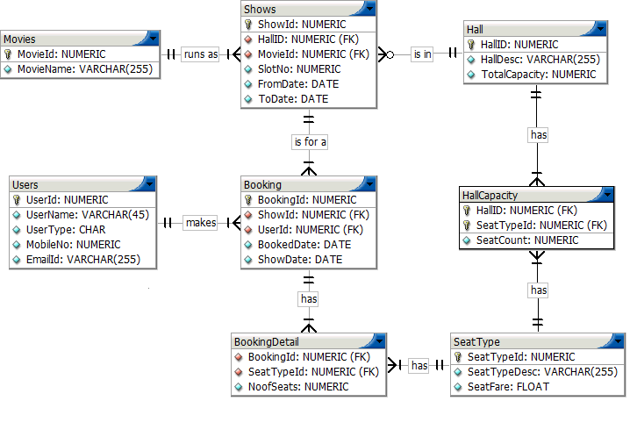

Create the database for this ER diagram – tables, columns, relationships and constraints. Insert appropriate data into all tables.

You may consider following values for these columns:

* Hall capacities: 200, 250, 300
* Seat types: Regular (R), Executive (E), Premium (P)
* User types: Administrator, Customer
* Email id columns should contain a @ and . (i.e. Dot)
* Slot no.s: are 1 to 4, where 1 = 10:30 AM, 2 = 2:00 PM, 3 = 5:00 PM and 4 = 8:00 PM
* Assume sizes of columns if not specified
* *ShowID* and *BookingID* should be automatically incremented when inserting new rows

Write queries for following requirements which would be used by the front-end programs:

1. For a given booking id (say 60001), calculate its total no. of seats and total fare
2. Given a seat type (say REGULAR), show the no. of times it's booked for a given date range
3. Show utilization of all halls for show date 15-Feb-2015 (no. of occupied seats vs. total seats)
4. List the total earnings from all movies for year 2015.
5. Show seat type-wise total booking (i.e. total no. of seats) and earnings for movie SHOLAY.
6. Create a view to display show details: Movie name, Hall id & description, Slot timing ('HH:MI AM/PM' format )and From date ('DD-MON' format). Order by movie name, from date, hall id.